Please Help Us! Share YOUR evangelism story(s) in the new book we are creating with CEPI:
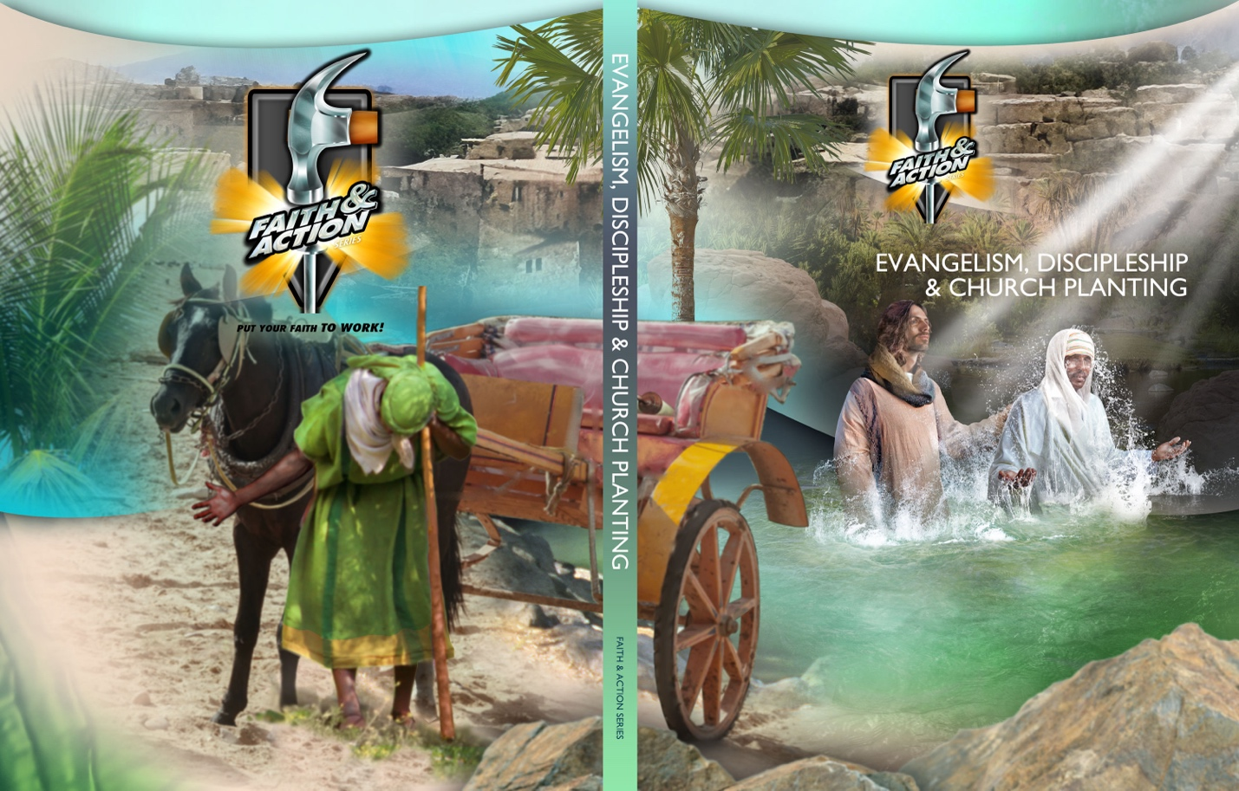
As our thank you, come by our table and receive a free Faith & Action book ($30 retail).
Choose ANY of these 7 methods of evangelism:
Methods of Evangelism | Examples
1. Direct Approach | Peter in Acts 2. Philip at Samaria (Acts 8)  Asking a stranger: Suppose you died today and stood at the gates of heaven, and found them closed. What would you answer if an angel asked you, “Why should I open the gates and let you in?”
2. Intellectual Approach | Paul at Athens, reasoning with philosophers about the unknown God (Acts 17)
3. Testimonial Approach | Sharing your story about how you became a follower of Jesus.  The woman of Samaria who left the well to tell others about Jesus (Jn. 4).
4. Friendship  Approach | Phillip discovered Jesus, and then went to tell his brother, Nathaniel (Jn. 1:48).
5. Invitational Approach | Invite someone to events, such as: a home group. a meal, a Bible study, a musical event, a special evening for women or men; a Bible story for children; an event for youth; a breakfast for men, with a special speaker; a church picnic or ball game; a Christian movie, like the Chosen; a Church bake sale
6. Service Approach | Tutoring students; neighborhood cleanup; meals, groceries or clothes for people in need; painting a school classroom; praying with the sick; visiting the elderly, reading the Bible to them and just taking time to talk with them.
7. Other Approach?

Your name ___________________ _________________________________ Cell: ______________________
Email _____________________________________________________________________________________
Your photo to put with your story in the new book (Please attach)
7 Questions to Answer As You Share Your Story
Question 1: (Title) What is the title of your story (About 5 words or less).

Question 2: (Introduction) What is your story about? Example: This story is about how I used the _________ approach of evangelism to connect _________(person) with Christ and our new church.

Question 3: (Goal) What was your goal?

Question 4: (Challenges) What challenges did you face?

Question 5: (Keys) How did the Holy Spirit help you succeed?

Question 6: (Result) What is the result of this evangelism story?

Question 7: (Action steps) What recommendations do you have for others practicing evangelism?

Please complete this form and return to us via text, email, or in writing at our table.
Faith & Action Contacts:
Cell: 417-619-3538 Email: Elizabeth@FaithAndActionSeries.org Table # _______
Websites to download form:
7 Questions to Answer As You Share Your Story
www.SerieFeYAccion.org/CMN
www.FaithAndActionSeries.org/CMN

